# Chapter : System Design



## Design

### Model View Controller Architecture

The system is built following the Model View Controller, MVC, architecture. The model handles the data logic, database communication, and data on database. The controller contains the core business and implementation logic. It also acts as the intermediary between the model and view and helps render views via routes. The view renders the pages and acts as the presentation part of this system. As MVC is one of the most popular and efficient design architectures for web-based systems, we chose to use MVC architecture for this system.

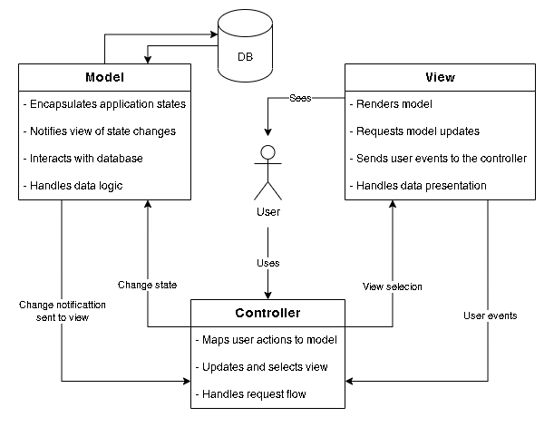

Figure .1: Model View Controller architecture

## Study of Algorithms

Collaborative filtering uses algorithms to filter data from user reviews to make personalized recommendations for users with similar preferences. Collaborative filtering is a method of making automatic predictions (filtering) about the interests of a user by collecting preferences or taste information from many users.

Collaborative filtering can broadly be implemented by two approaches; the user based and the item based. The user-based approach uses data from the various users to find similarities and then recommend while the item-based approach uses data from the various items to find similarities and then recommend.

Furthermore, collaborative filtering can be implemented using memory-based, model-based, hybrid, or deep learning methods. Memory-based approach uses similarity calculation and weighted average rating method. Model based approach develops a model using different data mining, machine learning algorithms to predict users' rating of unrated items. The hybrid approach combines the memory-based and the model-based CF algorithms. These overcome the limitations of native CF approaches and improve prediction performance. Deep learning technique is a recent method that uses neural and deep-learning techniques. While deep learning has been applied to many different scenarios, it is not effective when used in a simple collaborative recommendation scenario.

### Item-based Collaborative Filtering

The system utilises an item based collaborative filtering algorithm. Rather than matching the user to similar customers, item-to-item collaborative filtering matches each of the user’s purchased and rated items to similar items, then combines those similar items into a recommendation list. Cosine similarity and Pearson correlation are the most commonly used method to calculate the similarity scores used for the collaborative filtering process.

### Memory-based Approach

Memory-based approach typically uses neighbourhood-based algorithms to calculate the similarity between two users or items, and produces a prediction for the user by taking the weighted average of all the ratings. Similarity computation between items or users is an important part of this approach. Multiple measures, such as Pearson correlation and vector cosine-based similarity are used for this. Despite of its problems with sparse data, it is a highly effective method due to the results being explainable, method itself being easy to use, new data being easier to facilitate into the system, and having good scalability with co-related items.

### Cosine Similarity

Cosine similarity is a measure of similarity between two sequences of numbers. The cosine similarity always belongs to the interval [-1, 1]. The cosine of two non-zero vectors can be derived by using the Euclidean dot product formula:

$$A.B= \left|\left|A\right|\right|.\left|\left|B\right|\right|.\cos{θ}$$

Given two n-dimensional vectors of attributes, A and B, the cosine similarity, cos(θ), is represented using a dot product and magnitude as:

$$S_{c}\left(A, B\right)=\cos{(θ)}= \frac{A. B}{\left|\left|A\right|\right| . \left|\left|B\right|\right|}= \frac{\sum_{i=1}^{n}{A_{i}.B_{i}}}{\sqrt{\sum_{i=1}^{n}{A_{i}^{2}}}. \sqrt{\sum_{i=1}^{n}{B_{i}^{2}}}}$$

where Ai and Bi are components of vector A and B respectively.

### Weighted Average

Weighted average is a calculation that takes into account the varying degrees of importance of the numbers in a data set. In calculating a weighted average, each number in the data set is multiplied by a predetermined weight before the final calculation is made.

$$W= \frac{\sum_{i=1}^{n}{w_{i}X_{i}}}{\sum_{i=1}^{n}{w_{i}}}$$